Project Design Phase-II
Technology Stack (Architecture & Stack)

Date | 30 September 2026
Team ID | SWTID-2026-4912
Project Name | AI WeatherWise
Maximum Marks | 4 Marks

Technical Architecture:
The Deliverable shall include the architectural diagram as below and the information as per the table1 & table 2
Technical Architecture Diagram: AI WeatherWise
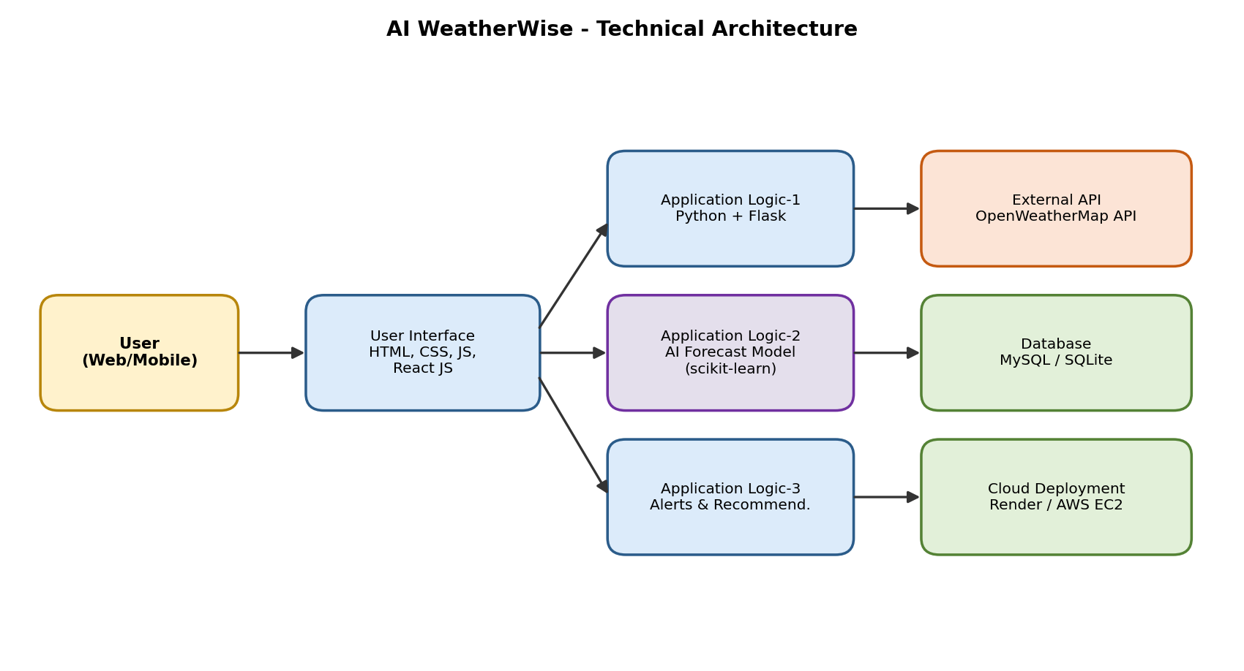
Table-1 : Components & Technologies:
S.No | Component | Description | Technology
 | User Interface | Web dashboard where the user searches a city and views weather, forecast, AI insights and alerts | HTML, CSS, JavaScript, React JS
 | Application Logic-1 | Backend REST API for authentication, city search, and fetching / processing weather data | Python (Flask / FastAPI)
 | Application Logic-2 | AI insight generation: plain-language summary and personalised tips from weather data | Python, Generative AI (LLM) API
 | Application Logic-3 | Alert engine: checks severe-weather thresholds, sends alert emails and daily briefing | Python, APScheduler, SMTP
 | Database | User profiles, favourite cities, alert preferences and weather history | MySQL / SQLite
 | Cloud Database | Managed database service used in the deployed version | Firebase Firestore / AWS RDS
 | File Storage | Application logs, trained ML model file and static assets | Local Filesystem / AWS S3
 | External API-1 | Live weather, hourly / 7-day forecast and air-quality data | OpenWeatherMap API
 | External API-2 | Converting city names to coordinates and detecting the user's location | OpenWeather Geocoding API, Browser Geolocation API
 | Machine Learning Model | Predicts short-term rain probability from historical weather data | scikit-learn (Random Forest / Logistic Regression), pandas
 | Infrastructure (Server / Cloud) | Local Server Configuration: Python 3.11, Flask on localhost:5000.  Cloud Server Configuration: Gunicorn + Nginx on Render / AWS EC2 (t2.micro) | Local, Render / AWS

Table-2: Application Characteristics:
S.No | Characteristics | Description | Technology
 | Open-Source Frameworks | React JS for UI, Flask / FastAPI for backend, scikit-learn and pandas for ML, Chart.js for charts | React, Flask, scikit-learn, pandas, Chart.js
 | Security Implementations | Password hashing, HTTPS / TLS, token-based authentication, API keys in environment variables, input validation (OWASP Top 10) | bcrypt / SHA-256, JWT, HTTPS, OWASP
 | Scalable Architecture | 3-tier architecture (UI, API, database) with a stateless backend that can scale horizontally | 3-tier, REST, Docker
 | Availability | Cloud hosting with health checks and auto-restart; cached data is served if the external API is down | Render / AWS, load balancer, caching
 | Performance | Caching of API responses (10-minute TTL), gzip compression, CDN for static files; target of about 100 requests per second | Redis / in-memory cache, Gunicorn workers, CDN

References:
https://c4model.com/
https://developer.ibm.com/patterns/online-order-processing-system-during-pandemic/
https://www.ibm.com/cloud/architecture
https://aws.amazon.com/architecture
https://medium.com/the-internal-startup/how-to-draw-useful-technical-architecture-diagrams-2d20c9fda90d

